Directions: Create a map overly displaying where different types of subsistence agriculture occurs. Your key should include: Shifting cultivation, Intensive Subsistence (wet rice dominant), Intensive Subsistence (wet rice not dominant), and Pastoral Nomadism.
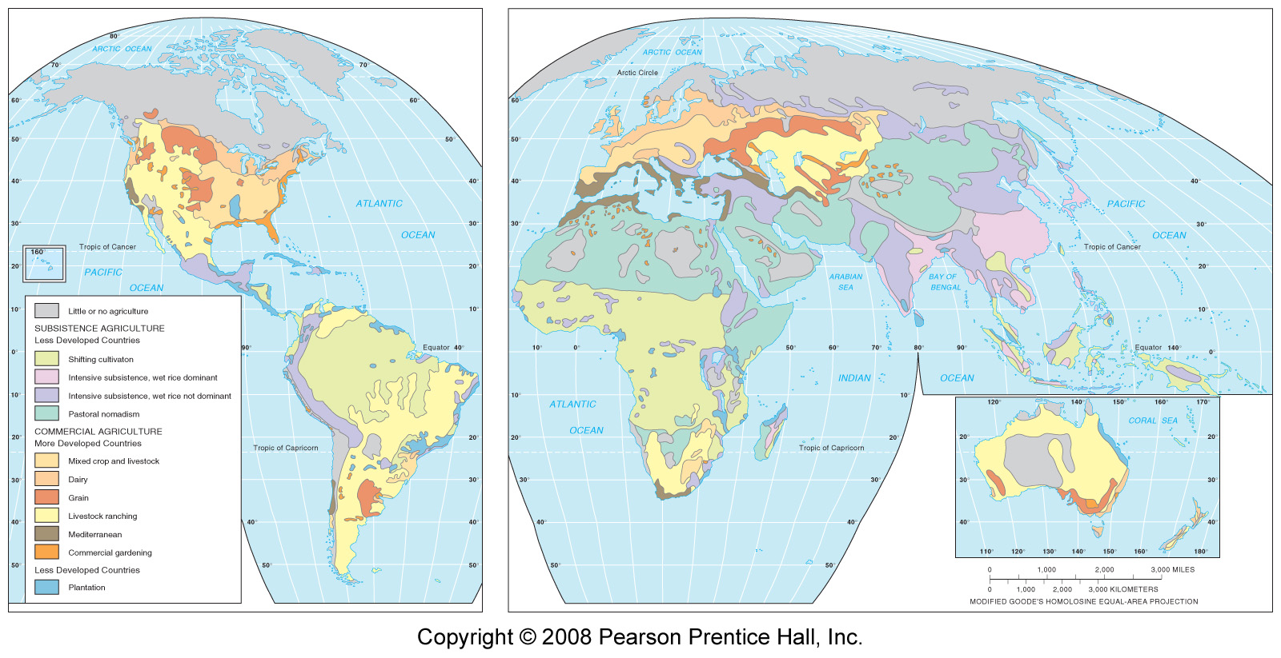

Directions: Create a map overly displaying where different types of commercial agriculture occurs. Your key should include: Mixed crop and livestock, dairy, grain, Mediterranean, livestock ranching, commercial gardening, and plantation. Subsistence (wet rice dominant), Intensive Subsistence (wet rice not dominant), and Pastoral Nomadism.

Directions: Shade each cultural hearth in the color of your choice. Next to each hearth, write the crops and domesticated animals associated with the hearth.

