Change Over Time Exhibit: Part 1 (70 Points)
Project Goal: Identify continuity (things that remain the same) and change in regions which have been colonized.
- You will make three 8.5” x 11” “mini-posters” which describe your country before, during, and after colonization and adhere them to a trifold or poster board in order to present you information to the class.
- You will complete the “Continuity and Change” graphic organizer and adhere it to your poster presentation.
Select a country located in Africa or Asia which was colonized by a European Country:_______________________
- Poster 1: Your Country Pre- colonization
- Poster 2: Your Country During Colonization
- Poster 3: Your Country Post-Colonization
- Each Poster must have a summary paragraph, summarizing the main political, economic, religious, or social characteristics of the country during that time period. You must describe 3 of the 4 possible topics.
- Each poster must include a primary source visual, annotations, and a summary that meets the requirements below. An example is found on the following page:
- You must CITE your sources using MLA format. Your project will not be graded unless you have cited your sources!

PRIMARY SOURCE VISUALS
Options to Choose From | Parameters | Components Checklist
- Map  - Artifact  - Chart  - Graph  - Picture/Photo/ Painting  - Political cartoon  - Propaganda Poster/ Other Poster  - Table  - Other?- Check with your teacher | - Visuals must be primary sources from the time period  - Visuals must be at least the size of a ½ sheet of paper and no bigger than 2 sheets of paper  - They must include thought bubble annotations out to the side addressing Who, What, Where, When , Why, and How (see attached for an example) | - Visual is a primary source  - Visual is appropriate size  - “Who” Thought Bubble  - “What” Thought Bubble  - “When” Thought Bubble  - “Where” Thought Bubble  - “Why” Thought Bubble

* Keep in mind that the names of countries have changed over time. In order to find out information about your country before colonization, you will probably need to focus on the main ethnic group that lived in the region. Remember that some of the colonies you signed up for changed their name after they became independent. You can look up their modern name, or compare your imperialism map to a modern map.*

Example
Title: Your Country Before Colonization

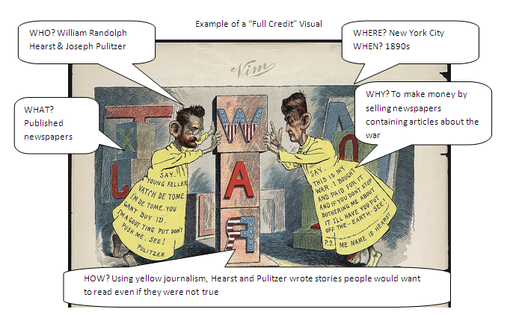
SUMMARY: Beneath your picture, write a paragraph summarizing the main political, economic, religious, or social characteristics of the country during that time period. Include information in the during/post-colonization poster of benefits or drawbacks gained during Colonization.

Continuity and Change Graphic Organizer
Should be completed in Class on Monday, November 16th.
Country:

Continuity | Change

PART 2: MODERN COMPARISONS (20 Points)
Should be completed in Class on Monday, November 16th.
Access the CIA World Factbook. Look up the country you chose and fill in the information for that column. Then do the same for the European mother country. Pick 3 parts of the chart where there is a large difference between the numbers for the colony and the mother country. Provide your thoughts on what the data means in the column listed Discrepancies.
RULES FOR THE CHART:
- Always use percentages (if possible)
- Always use the most current dates
 | COLONY: _______________ | MOTHER COUNTRY: ____________________ | Discrepancies?
People and Society
Primary Religion & Percentage
Birth Rate
Urbanization (Urban Population)
Infant Mortality Rate
Physician Density
Obesity
Literacy (Total pop.)
Child Labor (Percentages)
Government
Government Type
Independence Date |  | N/A

 | COLONY: _______________ | MOTHER COUNTRY: ____________________ | Discrepancies?
Economic
GDP per capita
Industrial Production Growth Rate
Unemployment Rate
Population Below Poverty Line
Exports
Debt- External

Part 3: MODERN CONFLICT CASE STUDIES Gallery Walk (20 Points)
Will be completed in Class using other student assignments on Tuesday, November 17th.
 | #1-____________ | #2-______________ | #3-_______________ | #4-____________ | #5-____________
MOTHER COUNTRY
DATE OF INDEPENDENCE
Effects of Colonization
Do you think colonization had a positive or negative impact? Explain.

Part 4: Presentation (20 Points)
This will be completed out of class before Tuesday, November 17th.
You will be presenting your information to the members of your class.
Before you arrive on Tuesday, you need to prepare a short presentation (2-3 minutes). Your presentation should be written on notecards which you will turn in after you have presented. You will have pre which addresses:
- What are important aspects of the original civilization in the region you studied?
- Who colonized the region?
- How colonization did affected the region?
- When and how did your region gain independence?
- What life is like in the region today?
- What stayed the same and what changed in your region?

